# FLAPPY BIRD GAME

Internship-I Report Submitted in partial fulfilment of the requirement for undergraduate degree of

### Bachelor of Technology

In

## COMPUTER SCIENCE AND ENGINEERING

By

S GOPAL REDDY

**HU21CSEN0500086**

Under the Guidance of

**Dr. Sreerama Murthy M** Professor



Department Of Computer Science and Engineering GITAM School of Technology

GITAM (Deemed to be University) Hyderabad-502329

Dec-2023

# DECLARATION

I submit this industrial training work entitled **“Flappy bird game project**” to GITAM (Deemed To Be University), Hyderabad in partial fulfilment of the requirements for the award of the degree of “**Bachelor of Technology**” in “**Computer Science and Engineering**”. I declare that it was carried out independently by me under the guidance of **Dr. Sreerama Murty M,** Professor, GITAM (Deemed To Be University), Hyderabad, India.

The results embodied in this report have not been submitted to any other University or Institute for the award of any degree or diploma.

Place: HYDERABAD Name: S. Gopal Reddy

Date: 20-12-2023 Roll No: HU21CSEN0500086

# ACKNOWLEDGEMENT

I extend my sincere gratitude to **Dr. Sreerama Murty M** sir, my mentor, for the invaluable guidance and support provided during my internship project. Your expertise, encouragement, and willingness to share knowledge have been instrumental in shaping the success of this endeavor.

I would also like to express my thanks to **GITAM Deemed University** for providing me with the opportunity to work on this meaningful project. The experience gained and skills developed under your guidance have significantly contributed to my professional growth.

I appreciate the collaborative and enriching work environment fostered by the entire **Computer Science Department.**

This internship has been a transformative learning experience, and I am grateful for the trust and support extended to me. I look forward to applying the knowledge and skills acquired here in my future endeavors.

Thank you.

Sincerely,

S GOPA REDDY

STUDENT OF BTECH

HU21CSEN050086

# ABSTRACT

Flappy Bird was a mobile game developed by Dong Nguyen and released in 2013. The game gained immense popularity due to its simple yet challenging gameplay. Players controlled a bird, guiding it through a series of pipes by tapping on the screen to make the bird flap its wings. The goal was to navigate the bird through the openings in the pipes without hitting them.

While Flappy Bird achieved viral success, Dong Nguyen decided to remove the game from app stores in February 2014, citing concerns about its addictive nature and the attention it was receiving. Despite its short-lived availability, Flappy Bird left a lasting impact on the mobile gaming industry and inspired numerous clones and adaptations.

In acknowledging Flappy Bird, it's important to recognize Dong Nguyen's creative contribution to the gaming world. The game's unexpected popularity and subsequent removal sparked discussions about the challenges and pressures faced by developers in the rapidly evolving mobile app landscape. Flappy Bird's legacy is a reminder of the unpredictable nature of success in the gaming industry and the influence a simple yet engaging concept can have on global audiences.

**Table of Contents**

## CHAPTER 1: Front end development

* 1. Introduction
  2. Importance of Front end development
  3. Types of Main Front end development
     1. HTML
     2. CSS
     3. Javascript

## CHAPTER 2: Flappy Bird game

2.1Introduction To Flappy Bird Game

2.2How to Implement Flappy Bird Game

**REFERENCES:**

1. https://www.geeksforgeeks.org/flappy-bird-game-in-javascript/
2. https://www.w3schools.com/html/
3. <https://www.geeksforgeeks.org/css/>

4. https://www.javatpoint.com/javascript-tutorial

# CHAPTER 1:FRONT END DEVELOPMENT

## INTRODUCTION:

A front-end developer is a type of software developer who specializes in creating and designing the user interface (UI) and user experience (UX) of websites and web applications. The primary responsibility of a front-end developer is to ensure that the visual and interactive aspects of a website or application are user-friendly, aesthetically pleasing, and functionally efficient.

## IMPORTANCE OF FRONT END DEVELOPMENT:

**1.Improved User Experience -** A skilled frontend developer can ensure that your website is intuitive and easy to navigate. They can create a seamless user experience that encourages users to spend more time on your website, increasing the likelihood of conversions.

2.Faster Website Load Times - A skilled frontend developer can optimise your website's performance to ensure that it loads quickly. This is important because slow load times can result in a high bounce rate and decreased user engagement.

3.Mobile Responsiveness - With the majority of users accessing the internet on their mobile devices, having a mobile-responsive website is highly important. A skilled frontend developer can ensure that your website is responsive across all devices and browsers, providing users with a consistent experience no matter how they access your site.

4.Better Search Engine Optimisation (SEO) - A skilled frontend developer can optimise your website for SEO, making it easier for search engines to crawl and index your site. This can help improve your website's ranking on search engine results pages, increasing your visibility and driving more traffic to your site.

5.Brand Consistency - A skilled frontend developer can ensure that your website is consistent with your brand identity. This includes incorporating your brand colours, logos, and fonts into the website's design, creating a cohesive brand experience for your user

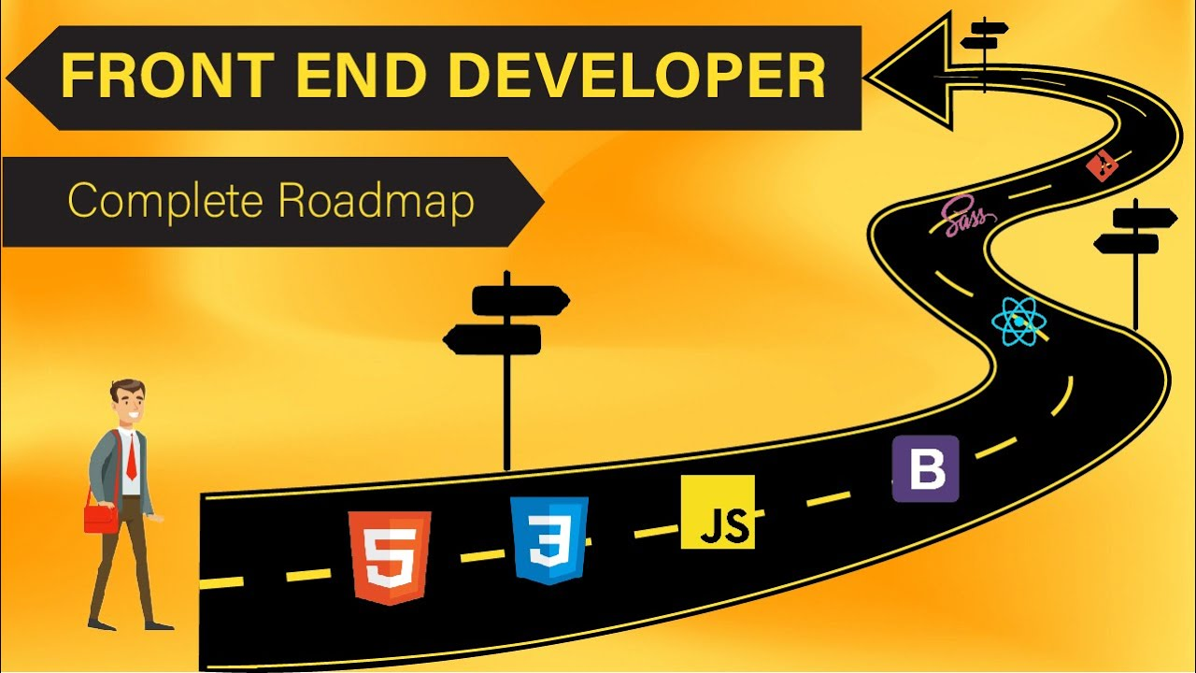

**Fig Front end road map**

## 1.3TYPES OF FRONT END DEVELOPMENT:

## 1.3.1 HTML:

HTML stands for Hyper Text Markup Language.HTML is the standard markup language for Web pages.HTML elements are the building blocks of HTML pages.HTML elements are represented by <> tags

HTML elements can have attributes Attributes provide additional information about the element.Attributes come in name/value pairs like charset="utf-8"

HTML elements are the building blocks of HTML pages.The <!DOCTYPE html> declaration defines this document to be HTML5

* The <html> element is the root element of an HTML page
* The lang attribute defines the language of the document
* The <meta> element contains meta information about the document
* The charset attribute defines the character set used in the document
* The <title> element specifies a title for the document
* The <body> element contains the visible page content
* The <h1> element defines a large heading
* The <p> element defines a paragraph

**HTML Headings:** HTML headings are defined with <h1> to <h6> tags.<h1> defines the most important heading. <h6>

**HTML Paragraphs:** HTML paragraphs are defined with <p> tags

**HTML Links:** HTML links are defined with <a> tags:

**HTML Images**: HTML images are defined with <img> tags.

The source file (src), alternative text (alt), width, and height are provided as attributes:

Example:<img src="img_w3schools.jpg" alt="W3Schools" style="width:120px;height:150px"

**HTML Buttons:** HTML buttons are defined with <button> tags:

Example**:**<button>Click me</button>

**HTML Tables:** An HTML table is defined with a <table> tag. Table rows are defined with <tr> tags. Table headers are defined with <th> tags. (bold and centered by default). Table cells (data) are defined with <td> tags.

**1.3.2 CSS:**

CSS (Cascading Style Sheets) is a vital web development language that dictates the visual presentation of HTML elements. CSS plays a crucial role in defining the visual presentation and layout of web pages. Here's a breakdown of its key uses:

1. Styling Text:

* Controlling font family, size, color, weight, and style
* Adjusting line height, spacing, and alignment
* Transforming text (e.g., uppercase, lowercase, capitalization)
* Creating visual effects like shadows, outlines, and text decorations

2. Handling Backgrounds and Borders:

* Setting background colors, images, and gradients
* Adding borders with different styles, widths, and colors
* Styling individual sides of elements with border properties

3. Structuring Layout:

* Positioning elements using methods like float, position, flexbox, and grid
* Creating columns and rows for content organization
* Spacing elements with margins and padding

4. Creating Visual Effects:

* Implementing transitions and animations for elements
* Applying gradients, shadows, and other dynamic effects
* Using filters for visual transformations (e.g., blur, grayscale)

5. Handling Responsive Design:

* Adapting layouts for different screen sizes and devices using media queries
* Creating flexible and fluid designs that adjust seamlessly

**1.3.3 Javascript:**

JavaScript is a scripting language for creating dynamic web page content. It creates elements for improving site visitors’ interaction with web pages, such as dropdown menus, animated graphics, and dynamic background colors.

**JavaScript Used For:**

1. Web and Mobile Apps

2. Building Web Servers and Server Applications

3. Interactive Behavior on Websites

4. Game Development

**CHAPTER 2: FLAPPY BIRD GAME**

**2.1 Introduction To Flappy Bird Game:**

Flappy Bird is a mobile game developed by the Vietnamese video game artist and programmer Dong Nguyen, under his game development company.Gears. The game is a side-scroller where the player controls a bird, attempting to fly between columns of green pipes without hitting them

**Objective:** Your goal is to guide a small, pixelated bird named Faby through pairs of green pipes with equally sized gaps. Faby continuously flies to the right, and you control its flight path by tapping the screen. Each tap makes Faby flap its wings and briefly ascend.

**Challenges:**The gaps between the pipes are randomly sized and spaced, making each run unique. Faby falls due to gravity, so you need to tap strategically to keep it above the ground and within the pipe gaps. Hitting a pipe or the ground ends the game.

**Scoring and Rewards:** Every successful passage through a pipe pair earns you one point.

The game tracks your highest score, adding an element of personal challenge.

Some versions offered medals or other rewards for achieving specific score milestones.

**2.2 How to implement flappy bird game:**

**HTML CODE OF FLAPPY BIRD:**

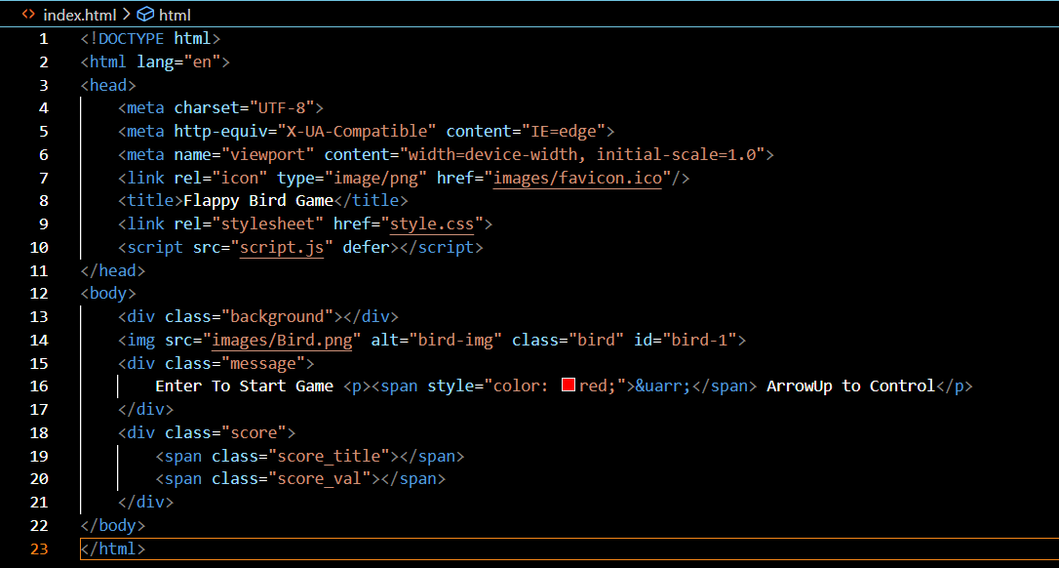

**1.<!DOCTYPE html>:** Declares the HTML version and document type as HTML5.

**2.<html lang="en">:** Defines the HTML root element with the language attribute set to "en" for English.

**3.<head>:** Contains metadata and links to external resources.

**4.<meta charset="UTF-8**">: Sets the character set to UTF-8 for proper text encoding.

**5.<meta http-equiv="X-UA-Compatible" content="IE=edge">:** Ensures compatibility with the latest version of Internet Explorer.

**6.<meta name="viewport" content="width=device-width, initial-scale=1.0">:** Configures the viewport for responsive design.

**7.<link rel="icon" type="image/png" href="images/favicon.ico"/>:** Sets the favicon (shortcut icon) for the webpage.

**8.<title>Flappy Bird Game</title>:** Sets the title of the webpage.

**9.<link rel="stylesheet" href="style.css">:** Links an external CSS file (style.css) for styling the webpage.

**10.<script src="script.js" defer></script**>: Links an external JavaScript file (script.js) with the defer attribute, indicating that the script should be executed after the HTML is parsed.

**11.<body>:** Contains the content of the webpage.

**12.<div class="background"></div>:** An empty div element likely used for the game background.

**13.<img src="images/Bird.png" alt="bird-img" class="bird" id="bird-1">: Displays** an image of a bird with the specified class and ID.

**14.<div class="message">:** A div for displaying a message related to game instructions.

15."Enter To Start Game" is displayed, and a paragraph with an arrow icon indicating control instructions.

**16.<div class="score">:** A div for displaying the game score.

**17.<span class="score_title"></span>:** An empty span for the score title.

**18.<span class="score_val"></span>:** An empty span for displaying the actual score value.

**CSS IMPLEMENTATION OF FLAPPY BIRD GAME:**

This CSS code is designed for styling a Flappy Bird game webpage. Let's break down the key elements:

*: Universal selector applies the following styles to all elements.

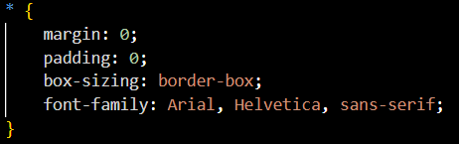

1.Sets default margin, padding, and box-sizing to border-box for all elements.

2.Specifies Arial, Helvetica, sans-serif as the default font family

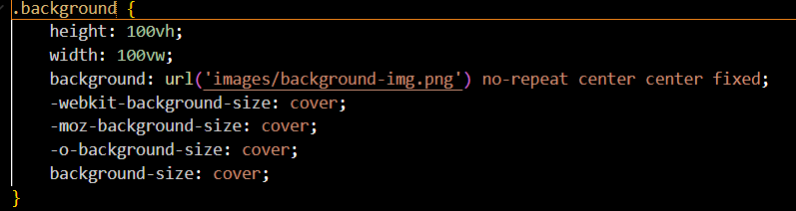

* .background: Styles for the game background.
* Sets the height and width to cover the entire viewport.
* Applies a background image with center-center positioning and fixed background attachment.
* Uses cover to ensure the background image covers the entire element.

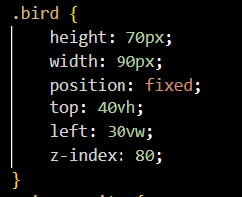

* .bird: Styles for the bird image.
* Sets the fixed position for the bird element on the page.
* Defines the initial size and positioning of the bird.

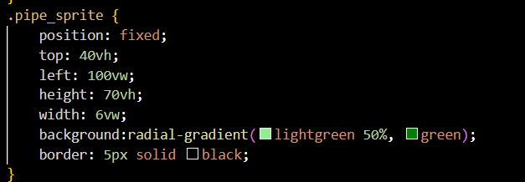

* Sets fixed position, size, and styling for the pipes using a radial gradient for a green color effect.

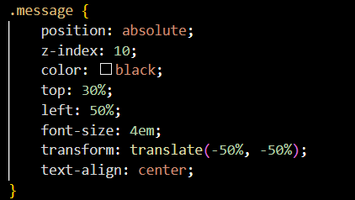

* Specifies absolute positioning, color, and centering for the game message.
* Uses transform to center the message horizontally and vertically.

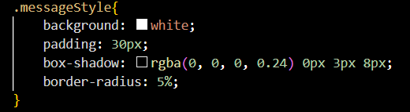

* Sets background color, padding, box shadow, and border-radius for the message box.

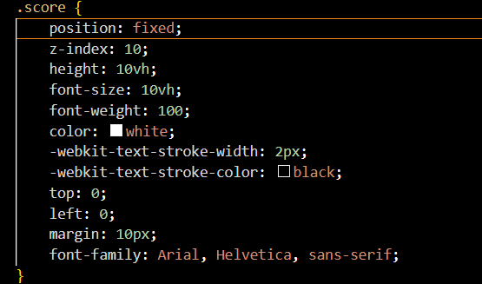

* Specifies fixed position, size, color, and styling for the game score.

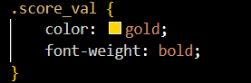

* Sets color and bold styling for the score value.

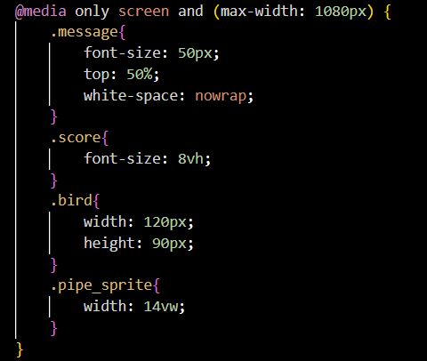

* @media only screen and (max-width: 1080px): Media query for responsive design.
* Adjusts styles for smaller screens, modifying font sizes and element dimensions for improved responsiveness.

**JAVASCRIPT IMPLEMENTATION OF FLAPPY BIRD GAME:**

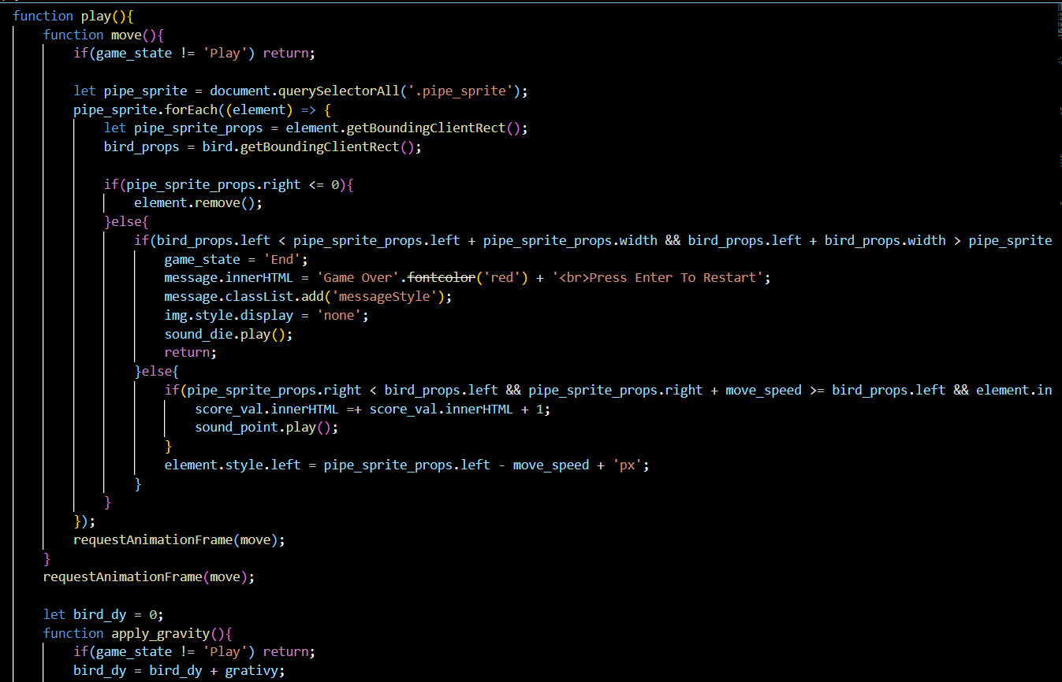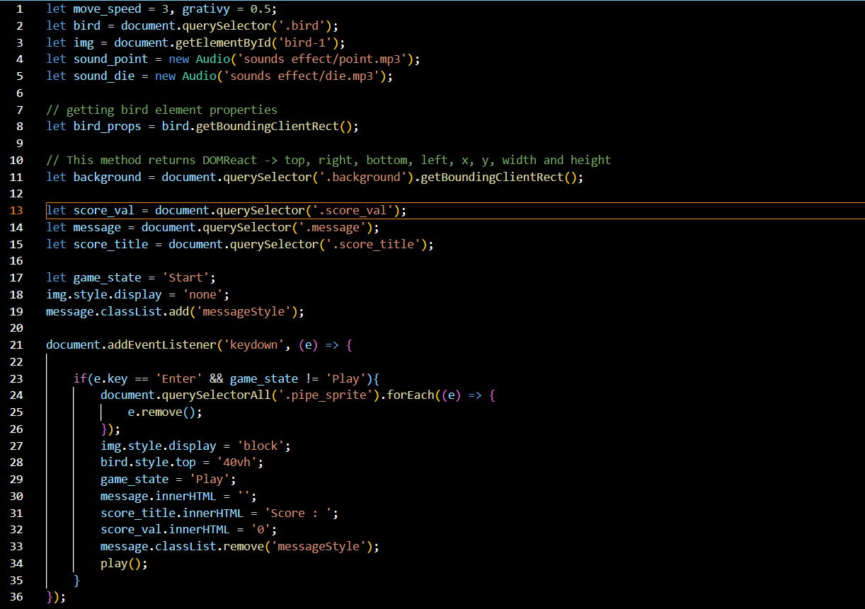

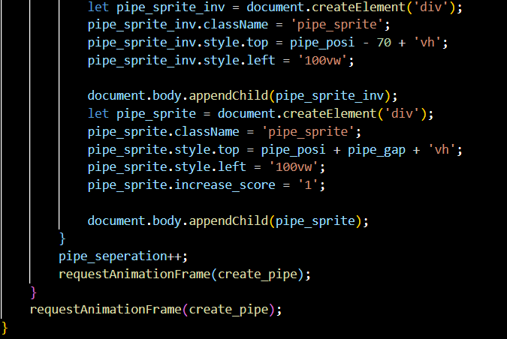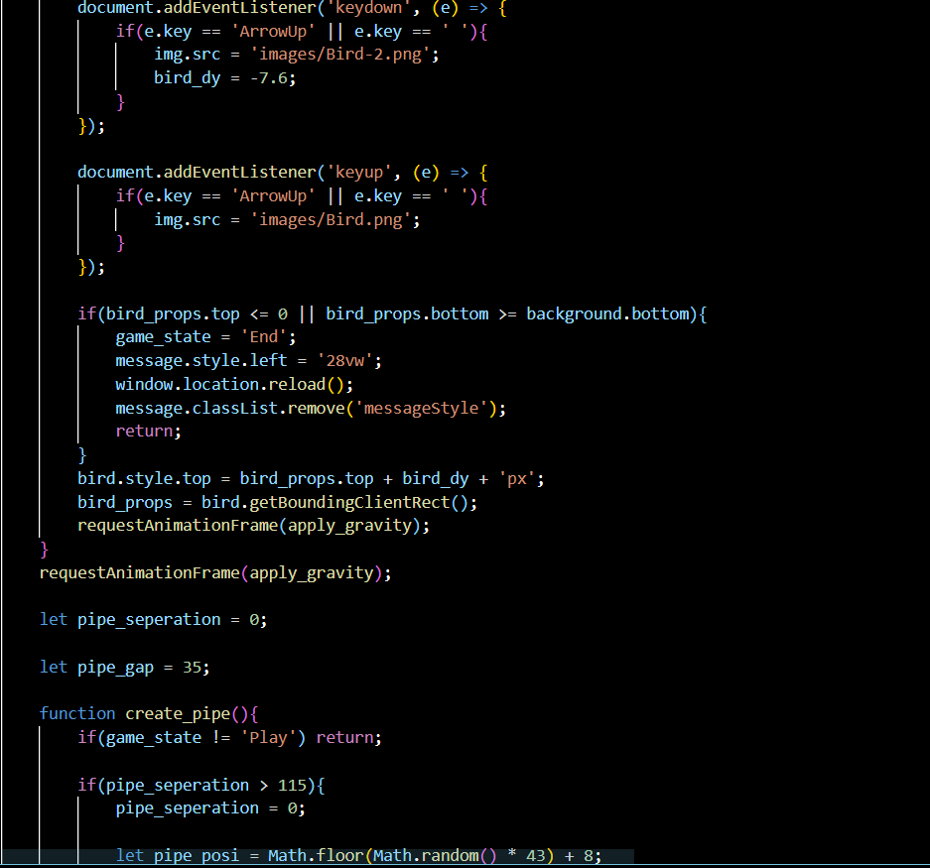

**Variables:**

* move_speed and gravity: Constants representing the speed of movement and gravity for the game.
* bird: Represents the bird element in the HTML.
* img: Represents the image element of the bird.
* sound_point and sound_die: Audio objects for point scoring and game-over sound effects.
* bird_props: Stores the properties (position, dimensions) of the bird element.
* background: Stores the properties of the background element.
* score_val, message, score_title: Elements for displaying and updating the score and game messages.
* game_state: Tracks the current state of the game (e.g., Start, Play, End).
* pipe_separation: Controls the separation between pipes.
* pipe_gap: Defines the vertical gap between pairs of pipes.

**Event Listeners:**

* Listens for the 'Enter' key press to start or restart the game when it is not in the 'Play' state.
* Removes existing pipes, resets the bird's position, and initializes game elements when starting or restarting.

**Functions:**

* play():
* Nested functions move(), apply_gravity(), and create_pipe() are defined within play() to control different aspects of the game.
* move(): Handles the movement of pipes, checks for collisions, updates the score, and triggers the game-over state.
* apply_gravity(): Implements gravity, allows the bird to jump on key presses, and checks for collision with the top and bottom boundaries.
* create_pipe(): Creates pairs of pipes with random positions, initiates the pipe separation, and controls the vertical gap.

**Event Listeners inside apply_gravity():**

* Listens for the 'ArrowUp' key press to make the bird jump and change the bird's image accordingly.
* Listens for the 'ArrowUp' key release to change the bird's image back.

**RequestAnimationFrame:**

* Utilizes requestAnimationFrame for smooth animations and updates.

**Collision Detection:**

* Checks for collisions between the bird and pipes, triggering the game-over state if a collision occurs.

**Score Update:**

* Updates the score when the bird successfully passes through a pair of pipes.

**Game-Over State:**

* Sets the game state to 'End' on collisions or when the bird goes out of bounds.
* Displays a game-over message and restart instructions.